# Clients

* Administrator
  + Manages system configuration settings such as:
    - Stations
    - Operator Checklists
    - Scrap Report
    - Network settings
    - + many more configuration constants
* Supervisor
  + Manages travelers
  + Manages User creation
  + Downloads production report
  + Downloads scrap report
* Operator
  + Login to any station
  + Complete parts
  + Scrap parts
  + Submit completed parts to the next station (if in Batch mode)
  + Prints labels

# User Creation

1. Click the options button:
2. Click “New User”:
3. Fill in *ALL* fields: 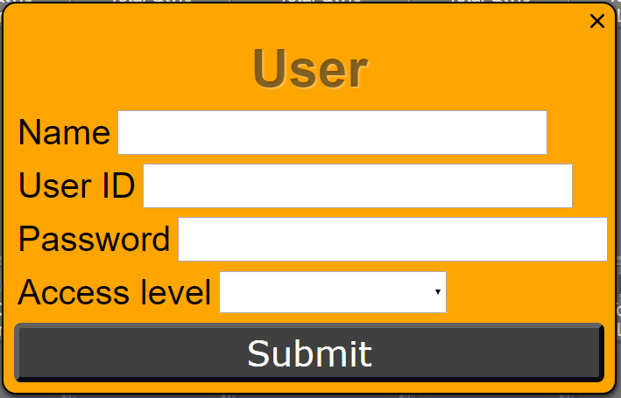

# Travelers

* Queue Items
  + Pre-Process items are colored blue
  + In-Process items are colored red
  + Post-Process items are colored green
  + Travelers with a quantity of zero are transparent, therefore display the color of the background

# Flagging issues

## Operator

1. Scan/search the item ID
2. Click “Flag Item”
3. Fill out the form and submit

## Supervisor

1. Place the carat in the search box and scan/search the item ID
2. Click ”Flag Item” on the right
3. Fill out the form and submit

# Rework | Scrap | Deflag

1. Scan/search the item ID
2. If not flagged, flag the item for a reason
3. Click “View Details”
4. Click the button of your choice

# Troubleshooting

## V2.4 / V2.6

* Missing labels (labels failed to print)
  1. From the supervisor client, search the exact item identification number found under the barcode, or place the carat in the search bar and scan the item’s barcode
  2. If the item was found, the item popup will appear
  3. Click “Print Labels” on the right
  4. Select label type
  5. Do not change quantity for single items (pack labels print 2)
  6. Select the printer (4x2FloorTableBox – pack labels)
* Need information about finished item
  1. From the operator client, login to the Finished station
  2. Scan the item twice
* “Traveler does not exist” message
  1. The traveler has most likely been considered Finished by the system the previous day, and was not brought back in
  2. Nothing can be done about this
* Running travelers outside of EATS
  1. If a traveler is known to be completed, it can safely be finished from the supervisor client
  2. Search the ID
  3. Click “Manually Finish”
  4. This traveler should not be in the system the following day